RESOLUTION NO.__________

RE: CERTIFICATE OF APPROPRIATENESS UNDER THE
PROVISIONS OF THE ACT OF THE PENNSYLVANIA
LEGISLATURE 1961, JUNE 13, P.L. 282 (53
SECTION 8004) AND BETHLEHEM ORDINANCE NO.
3952 AS AMENDED.

WHEREAS, it is proposed to secure a COA to build a four-story building, with revision: install an ornamental upper cornice at 13 West Morton Street.

NOW, THEREFORE, BE IT RESOLVED by the Council of the City of Bethlehem that a Certificate of Appropriateness is hereby DENIED for the proposal.

Sponsored by: (s)

(s)

ADOPTED BY COUNCIL THIS DAY OF

(s)
President of Council

ATTEST:

(s)
City Clerk

HISTORIC CONSERVATION COMMISSION

CASE #672 -- It is proposed to build a four-story building, with revision: install an ornamental upper cornice at 13 West Morton Street.
OWNER / APPLICANT: Dallas Basha

The Commission upon motion by Mr. Cornish and seconded by Mr. Traupman adopted the proposal that City Council DENY a Certificate of Appropriateness for the proposed work as presented (with modifications) described herein:

- It is proposed to install an ornamental upper cornice on a new four-story, mixed-use building; proposed fiberglass cornice measures approx. 34” high and painted to match other trim.
- The motion to DENY the proposed work was approved: 8 in favor, with 1 abstention; therefore, the proposal to secure a COA for installing an ornamental upper cornice on a new four-story, mixed-use building was DENIED. Those voting in support of denying approval of the current proposal noted its failure to comply with conditions approved during a previous HCC recommendation and resulting Bethlehem City Council approval. HCC members specifically recalled approval of the new structure was predicated on the condition that the upper cornice be smaller in size than originally presented as well as match color and material of approved masonry cladding at the entry level. note: accompanying detail did not correspond with provided depiction of upper cornice on drawing of front façade

JBL: jbl
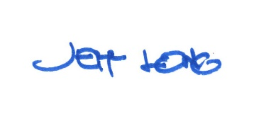

By:

Date of Meeting: November 19, 2018 Title: Historic Officer

